**1. Synopsis**

This project involves building an attendance system which utilizes facial recognition to mark the presence, time-in, and time-out of employees. It covers areas such as facial detection, alignment, and recognition, along with the development of a web application to cater to various use cases of the system such as registration of new employees, addition of photos to the training dataset, viewing attendance reports, etc.

This report explains the libraries and machine learning based models and algorithms that have been used for facial detection and recognition. Explanation and use of Django, along with an SQLite database for web application development and database management has been provided.

This project intends to serve as an efficient substitute for traditional manual attendance systems. It can be used in corporate offices, schools, and organizations where security is essential. The report also includes chapters covering project planning, methodology adapted and failures.

The modern face recognition attendance system is much efficient and safer than the conventional counterparts. There are a few attendance systems that are based on the face recognition technology and each of them has extremely varying features for the best suitability in different environments. it provides a facility for the central data management system.

It can capture multiple images of faces at the same time and process them individually. It can tolerate certain facial movement up to an extent. That is, from frontal to a different direction. It is the safest and fastest method of security. The system can be also used for places that require security like bank, military etc.

**2. Preamble**

**2.1 Introduction**

* Face Recognition is a biometric method of identifying an individual by comparing live capture or digital image data with the stored record for that person.
* Smart Attendance System is marking of attendance based on this technology, which provides an automated attendance system that is practical, reliable and eliminate disturbance and time loss of traditional attendance systems.

**2.2 Statement of Problems**

* Traditionally, employee’s attendances are taken manually by using attendance sheet which is a time-consuming event.
* Moreover, it is very difficult to verify one by one employee in a large organization with distributed branches whether the authenticated employee is actually responding or not.
* Smart Attendance system (SAS) using face recognition will present a system that can accurately evaluate employee’s performance depending on their recorded attendance rate.

**2.3 Objective and Scope of the Study**

Primarily the software will be based locally on the system to extract the features locally and then proceed with the identification of the face using those features on the server-side. The primary constraint of the software is correctly detected and identify the faces satisfying the detection threshold.

Furthermore, this project aims to automate the traditional attendance system where the attendance is marked manually. It also enables an organization to maintain its records like in-time, out time, break time and attendance digitally. Digitization of the system would also help in better visualization of the data using graphs to display the no. of employees present today, total work hours of each employee and their break time. Its added features serve as an efficient upgrade and replacement over the traditional attendance system.

Facial recognition is becoming more prominent in our society. It has made major progress in the field of security. It is a very effective tool that can help low enforcers to recognize criminals and software companies are leveraging the technology to help users access the technology. This technology can be further developed to be used in other avenues such as ATMs, accessing confidential files, or other sensitive materials.

Using this system any corporate offices, school and organization can replace their traditional way of maintaining attendance of the employees and can also generate their availability(presence) report throughout the month.

**2.4 Module Description with Functionality**

**2.4.1 Modules: -**

The features of the system are mainly divided into 3 modules.

**Registration and Login Module**

This module mainly deals with the functionalities related to the registration of any new employee to the organization, Log into the system and managing employee’s profile details. Using features provided by this module admin can register new employee to the system and admin / employee both can log into the system using their credentials.

**Manage Attendance Details**

This module mainly deals with the features related to the employee’s attendance. Using this employee can mark their presence, time-in and time-out in the system. Admin can see the availability report of each employee, employee can see his/her attendance report along with some possible filters such as filter by employee and filter by date.

**Manage Employee Details**

This module mainly deals with the features related to the employee’s profile. Using this admin can add a photo of the newly registered employee during registration. Admin can also command the system explicitly to train the model and system will make necessary calculation and will generate some data which will be used internally to identify each employee uniquely.

## 2.4.2 Functional Requirements

**Manage Registration and Login: -**

**Register new employee**

Description: Admin can register new

Input: Employee Details

Output: success message displaying the user has been created.

**Log-In to the system**

Input: User credentials

Output: If the credentials are correct, user will be redirected to the dashboard of the system

Exception Flow: If the entered credentials are incorrect then user will be redirected to the login page again displaying an error message.

**Manage Attendance Details: -**

**Mark your attendance-in**

Input: User will scan his/her face using the external web camera.

Output: system will identify the user uniquely and will mark his/her in-time to the database. The same success message will be transmitted to the user.

**Mark your attendance-out**

Input: User will scan his/her face using the external web camera.

Output: system will identify the user uniquely and will mark his/her out-time to the database. The same success message will be transmitted to the user.

**View my attendance report**

Description: Employee may often need to see his / her attendance record throughout the month or year. Using this feature one can see his / her attendance record till the date.

Input: User selection

Output: Statistical analytic of the particular employee who is currently logged into the system will be displayed.

**View employee’s attendance report**

Description: This feature is for admin. Admin can monitor the availability of each employee till the date. i.e., how many employees are present today out of total employees etc. can be monitored.

Input: user selection

Output: Attendance record of each employee including how many employees are present today out of total along with the availability graph.

**Manage Employee Details: -**

**Add photo of the employee**

Description: Admin only can access this feature. Admin can add a photo of an employee during the registration process.

Input: Username of an employee

Output: Success message record has been added.

Process: System will process an image and will generate necessary system data to identify each employee uniquely.

**Train the system**

Input: user selection

Output: system will process all the available records of the employees and will generate necessary system data to identify each employee uniquely.

**2.5 Methodology:-**

The face recognition system analyses video feed frame by frame for detection of faces. Then a predictor is used to identify the facial landmarks in the faces detected using a predefined template.

Using this template, the faces are aligned to increase the accuracy of the model. Now the unique embeddings of these aligned faces are generated. These embeddings are biometrics of the face and hence unique. These embeddings are classified using the classifier. This classifier is trained on theimages collected from the users beforehand to ensure the smooth workflow of the program.

**Significance of the Project**

This project serves as a foundation for future projects based on facial detection and recognition.

The report covers the libraries incorporated in this project for testing and optimization of machine learning algorithms. It also compares between algorithms with similar functionality. This project also covers web development and database management for a user- friendly UI.

We have used Histogram of Oriented Gradient for face detection and deep learning techniques to calculate and compare 128-d face features for face recognition. Once faces are detected and recognize with the existing database, system calculate attendance for the recognize employees.

**Division of the report**

The report has been divided into 8 sections.

The first section lays the foundation for Image Processing using OpenCV in live video streams.

The second section talks about different algorithms used for facial detection . It also covers facial landmarks used for face alignment to increase the accuracy for recognition. The third section discusses about facial recognition models tested in this project. The fourth section marks the beginning of web development. It talks about the architecture, project structure including the information on the management of databases and development of the front-end. Data visualization using graph plotting libraries and their examples are covered in the fifth section of the report.

**2.5.1 Image Processing with OpenCV**

OpenCV can be installed by building from source which can be downloaded from OpenCV’s website. Once it is downloaded, it can be imported using the command: import cv2

In order to load an image in OpenCV, the imread() method is used, in which the path of the image file is provided as a parameter. An image, once loaded, can be displayed using the imshow() method. Images are loaded as numpy arrays, and hence their dimensions can be retrieved usingthe shape attribute of numpy arrays. This provides another advantage - cropping images andextracting regions of interest is reduced to array slicing. Images can be resized using the resize()method. Rectangles,circles and text can be drawn onto an image using the rectangle(), putText()and circle() methods.

OpenCV loads images in BGR format which is not always desirable. Colorspaceconversions to Grayscale and RGB formats is achieved easily using the cvtColor() method. All of these methods are used throughout the project for image manipulation.

**Working with Video Streams**

OpenCV provides VideoCapture and VideoWriter classes to capture videos and save themon disk, respectively. In this project, VideoCapture objects have been used to work with webcamstreams. The VideoCapture() constructor takes one argument, which can either be a number,specifying the index of the camera device, or the path to a video file. Once a VideoCapture objectis created, it can be processed frame by frame, allowing us to apply the same image processingtechniques that we use for static images. The video capture can be released with the release()method.

**2.5.2 Facial Detection and Alignment:-**

Face detection is the technology of recognizing human faces in a photo, video or live frame.

Face detection can be said as a specific case of object-class detection. Face detection is the first step in the process of facial recognition. Face alignment, that can be thought of as data normalisation, is a part of image pre-processing, wherein, after detecting the face, the image is cropped, rotated, scaled and adjusted so as to provide a normalized input to the face classifier.

**Haar and LBP Classifier**

A classifier is defined as a program which can discriminate between a positive image and a negative image. Classifiers are trained on many positive (face containing) and negative images, so as to classify a new image correctly. OpenCV2 provides two pre-trained classifiers

1) Haar Classifier 2) LBP Classifier

1. **Haar Classifier**

Haar classifier works by extracting Haar features from the input image. The following figure illustrates the three kinds of Haar features and how they are used to extract features

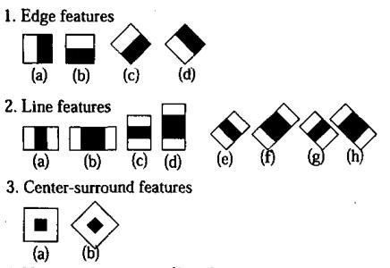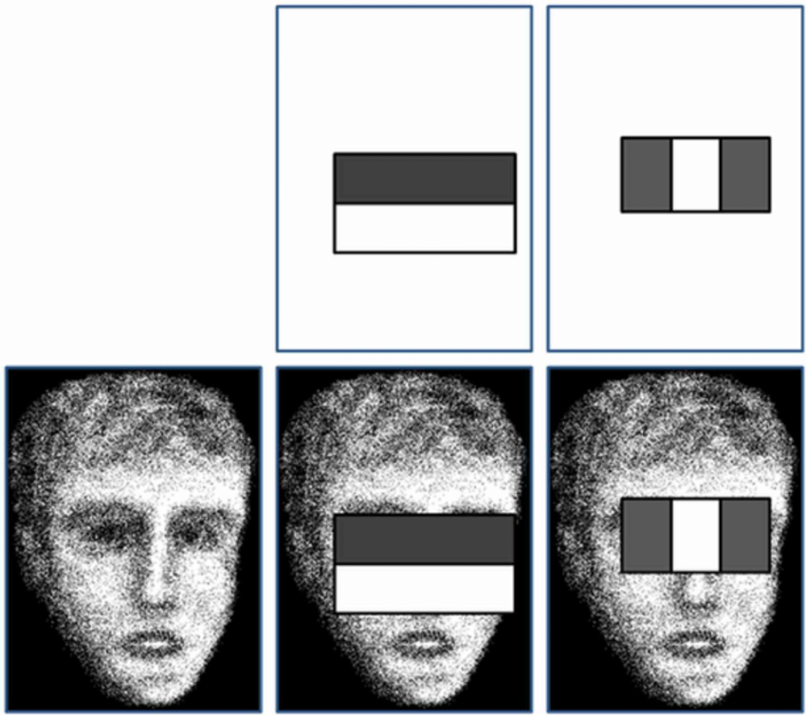

**Figure 2.5.2.** Placing (a)haar features on (b) image to calculate features3

Each of these windows is placed on the input image to calculate a single feature. A feature is a single value obtained by subtracting the sum of pixels under the white rectangle from the sum of pixels under the black rectangle. A large number of features are thus calculated for different positions and sizes of kernels on the entire image. Only relevant features are kept and irrelevant features are discarded through a technique called AdaBoost4.

1. **LBP Cascade Classifier**

LBP (Local Binary Patterns) is a visual/texture descriptor. It works by dividing the training image into blocks and analysing 3*3-pixel areas for each block. The center pixel’s value is compared with neighbouring pixels in the 3*3 window. The value of neighbor pixels whose current value is greater than the center pixel’s value is set to 1. Others are set to 0. Updated pixel values are then read in a clockwise manner and converted to a binary number. This number is converted to its decimal equivalent. The following figure illustrates this process.

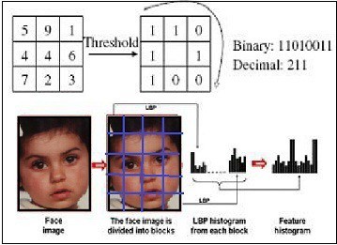

Figure 2. LBP Conversion to binary to decimal

The block values so obtained are converted to a histogram. Finally, these block histograms are concatenated to form one feature vector for one image.

**Dlib’s Detector**

Dlib is a general-purpose cross-platform software library written in C++. Its libraries are available for use in different programming languages. The Object detection task can be achieved using Dlib’s detectors such as Histogram of Oriented Gradients (HOG), or Convolutional Neural Network (CNN) based face detector.

**Histogram of Oriented Gradients (HOG) detector**

HOG is a feature descriptor used in computer vision and image processing for the purpose of object detection. It works on the concept of finding gradients along the x and y-axis. These gradients are added vectorially and information such as magnitude and direction of the gradients are extracted forming edges in the image. Now the whole gradient image is divided into 8*8- dimension matrix i.e. carrying 64 gradient vectors. Each matrix contains 9 bins and each bin has a range of 40 degrees to allocate the gradient vector lying in that range. After each gradient vector has been allocated a bin, a histogram of this matrix is formed which determines the overall direction and magnitude of the gradient. Luminosity plays a great role in the proper detection of gradients. To overcome this failure the value of the histogram is obtained in the red, green and blue frame and then normalized making it lighting invariant. Finally, the normalized histogram is compared with its default histogram for faces to identify a face in an image.

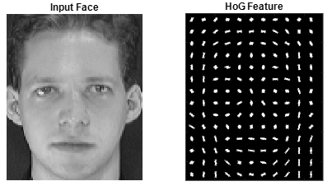

Figure 3. HOG Face detection

The following code is used to initialize the HOG based face detector:

hog_face_detector = dlib.get_frontal_face_detector()

**2.5.3 Facial Alignment using Landmark Predictors**

Face Alignment is the process of identifying the geometric structure of faces in digital images and then attempting to obtain an alignment of the face based on rotation, scale, and translation. There are many methods to imply facial alignment. In this project, face alignment is achieved with the help of facial landmarks.

Facial detection is an important step before facial recognition as most face recognition algorithms can benefit highly from applying facial alignment and normalizing the input. Higher accuracy is obtained when face alignment is used.

Dlib has a 5 point and 68 points facial landmark predictor. It extracts important landmarks on the face like left eye start point, the center of the nose, etc. The facial landmark points help us to perform operations using the point coordinates. The operations performed for facial alignment are: -

1) Rotation, such that the eyes lie on a horizontal line

2) Scaling, such that the size of faces is approximately identical

3) Translation, such that the image is centred

In this project, 68 points facial landmark predictor is used. The results can be seen in the following figure :-



Figure 4. Facial Alignment results

Code to initialize a 68-point landmark predictor:

predictor = dlib.shape_predictor('./shape_predictor_68_face_landmarks.dat')

**2.5.4 Facial Recognition**

A facial recognition system typically works by extracting face encodings from faces and comparing them with an existing database of known faces to find a match. Given an unknown image, the process of facial recognition comprises of detecting faces in that image, aligning them, extracting feature vectors from aligned faces and classifying each feature vector as belonging to one class from a set of classes.

In order to extract feature vectors, or face encodings, the team used Convolutional Neural Network based models. Three different approaches were tested by the team:

1. Training our own CNN based object classifier (face classifier)

2. Face_recognition library by Adam Gaitgey

**1) Training Our Own CNN based Object Classifier**

**Using Keras to build the CNN**

Keras is a high-level neural networks API, written in python, that runs on Tensorflow backend. The core data structure of Keras is a model which is a way to organize layers of a neural network. For this project, the sequential model available in Keras was used. Convolution2D, MaxPooling2D, Flatten and Dense layers were also used.

**Data Augmentation**

Data augmentation is a way to artificially expand the size of training data by creating modified versions of the images in the dataset. Data augmentation helps to increase the performance of the CNN as it improves with the amount of data available. Transforms include a range of operations from the field of image manipulation like shifts, zooms, flips, etc. The Keras deep learning neural network library provides the capability to fit models using image data augmentation via the ImageDataGenerator class.

**Training and Testing**

Once the CNN is built, it is trained on a number of classes, each having several training images. Once trained with images and associated labels, the CNN is expected to predict the associated label for an unknown image input.The training time of the CNN depends on the number of training images, the size of the batch, the number of times epochs, etc. In order to obtain high accuracy, it is necessary to train the CNN on a large dataset, which is computationally expensive and takes a lot of time. When trained and tested on a small dataset, the team was unable to get accurate results. Hence, for this project, the team decided to use pre- trained CNNs to extract encodings from images.

**2)Face Recognition library**

Face Recognition library works on deep metric learning10 tools to identify, train and classify test data. It is the world's simplest library for recognition and manipulation of faces. This model showed an accuracy of 99.38% on the Labeled Faces in the Wild benchmark indicated by python software foundation. The deep neural network used by it, represent the face on a 128- dimensional unit hypersphere. The embedding is a generic representation for anybody's face.

Unlike other face representations, this embedding has the nice property that a larger distance between two faces embeddings means that the faces are likely not of the same person. This property makes clustering, similarity detection, and classification tasks easier than other face recognition techniques where the Euclidean distance between features is not meaningful. This project has incorporated this library to extract the face encodings and face location from the images.

Code for Generating embeddings using Face Recognition library:

X_face_locations = face_recognition.face_locations(face_aligned)

Faces_encodings = face_recognition.face_encodings(face_aligned, known_face_locations=X_face_locations)

**2.6 Feasibility Study:**

**2.6.1 Feasibility Analysis**

A feasibility study evaluates the project's potential for success; therefore, perceived objectivity is an important factor in the credibility of the study for potential investors and lending institutions. . It must therefore, be conducted with an objective, unbiased approach to provide information upon which decisions can be based. Here, we discuss 3 major feasibility studies required for our project.

**2.6.2 Operational Feasibility**

Operational feasibility is the measure of how well a proposed system solves the problems with the users. Operational feasibility is dependent on human resources available for the project and involves projecting whether the system will be used if it is developed and implemented. The project is operationally feasible for the users as nowadays almost all the teachers/staffs are familiar with digital technology.

**2.6.3 Economic Feasibility**

Economic feasibility defines whether the expected benefit equals or exceeds the expected costs. It is also commonly referred to as cost/benefit analysis. The procedure is to determine the benefits and the savings expected from the system and compare them with the costs. A proposed system is expected to outweigh the costs. This is a small project with no cost for development. The system is easy to understand and use. Therefore, there is no need to spend on training to use the system. This system has the potential to grow by adding functionalities for students as well as teachers. This can Hence, the project could have economic benefits in the future.

**2.6.4 Technical Feasibility**

Technical feasibility is carried out to determine whether the project is feasible in terms of software, hardware, personnel, and expertise, to handle the completion of the project. It considers determining resources for the proposed system. As the system is developed using python, it is platform independent. Therefore, the users of the system can have average processing capabilities, running on any platform. The technology is one of the latest hence the system is also technically feasible.

**3. Review of literature**

This project involves building an attendance system which utilizes facial recognition to mark the presence, time-in, and time-out of employees. It covers areas such as facial detection, alignment, and recognition, along with the development of a web application to cater to various use cases of the system such as registration of new employees, addition of photos to the training dataset, viewing attendance reports, etc. This project intends to serve as an efficient substitute for traditional manual attendance systems. It can be used in corporate offices, schools, and organizations where security is essential.

**3.1 Web Application Development and Database Management**

The project involved the creation of a web application that would work as an attendance system that uses the facial recognition model described in previous sections. For the development of this application, Django was used. Django is a high-level Python-based, an open-source web framework that allows the creation of websites with ease. It follows the Model-Template-View (MTV) Architecture . Along with being secure, portable, scalable, and versatile, it takes care of the intricacies and hassle of web development, so that the developer can focus solely on writing the application.

**3.2 Project structure**

The command django-admin startproject my_project followed by django manage.py startapp my_app is used to initialise a django project named ‘my_project’ consisting of one application named ‘my_app’. The project thus has the following structure:

myproject/

manage.py

myproject/

__init__.py

settings.py

urls.py

Wsgi.py

myapp/

__init__.py

admin.py

models.py

tests.py

views.py

The views, models, and templates are thus separated, allowing us to harness the power of MTV architecture. The models.py file is where we define our database models. The templates contain HTML files which create the UI layer. The views.py file is used to communicate between the models and the templates. It consists of different functions, or views, which take in web requests and return web responses. As a result, the HTML contents of the associated template, along with linked CSS and JS files, are displayed as a web page, at the url mapped to that view.

This url mapping is specified in the urls.py file. Django views are linked with their corresponding contents using the render function, and data to be displayed is passed using the Django templating language.

**3.3 Database and Model**

This project uses the built-in User model provided by Django, which stores the information of all employees. This model can be imported using the following command:

from django.contrib.auth.models import User

This project also uses two other model classes ‘Present’ and ‘Time’ that store Attendance (present/absent) and time-in, time-out, respectively of all employees. The following code is used to create these two models:

**class Present(models.Model):**

user=models.ForeignKey(User,on_delete=models.CASCADE)

date = models.DateField(default=datetime.date.today)

present=models.BooleanField(default=False)

**class Time(models.Model):**

user=models.ForeignKey(User,on_delete=models.CASCADE)

date = models.DateField(default=datetime.date.today)

time=models.DateTimeField(null=True,blank=True)

out=models.BooleanField(default=False)

The user field acts as a foreign key to the User model. The date field stores the current date.

The present field is a boolean field that stores True for present, and False for absent. The time field stores the time of entry or exit, depending upon the value of the out field, which stores True for time-out, and False for time-in.

**3.3 Front end with Bootstrap and CSS**

Django is a very powerful framework, but it can't be used for front end development. In order to develop the website’s UI and UX, Bootstrap and CSS styling were used. These CSS files were stored in a separate static folder within the Django project. CSS- Cascading Style sheets are used for describing the presentation of a document written in a markup language such as HTML.

It allows the addition of styles to a webpage with the use of classes and IDs. Bootstrap is a front end framework that simplifies the process of adding styles, by providing built-in CSS classes that can be added to HTML elements, allowing the developer to forgo the process of writing complicated CSS.

For this project, Bootstrap was added via the Bootstrap CDN. The url of Bootstrap CSS files is simply added within the <link> tag of the HTML file, and Bootstrap classes can then be used throughout the file. The Bootstrap typography, navbar, table, button, card, container, alert classes were used extensively throughout the project.

**3.4 Django Template Language**

Django Template Language is used to send data from the view to the templates. It provides the developer with tags that function similarly to some programming constructs - such as the ‘if’ tag for boolean tests and the ‘for’ tag for looping. The templating language has been used throughout the project for interaction between the view and the templates.

**3.5 Tabular Representation of Attendance Data**

The application provides the admin with the feature to view attendance reports, where in attendance data is displayed as tables. This is achieved via Django’s ORM and Templating Language.

Data is fetched from the attendance database in the form of query sets, making use of Django’s ORM. These query sets are then passed to the template (HTML) files using Django’s templating language. These query sets can be displayed as a table by using the {% for tag %} of the templating language for displaying rows and outputting each attribute of the object in a different table cell (column).

The table formed using query set and its attributes are displayed in the following figure table).

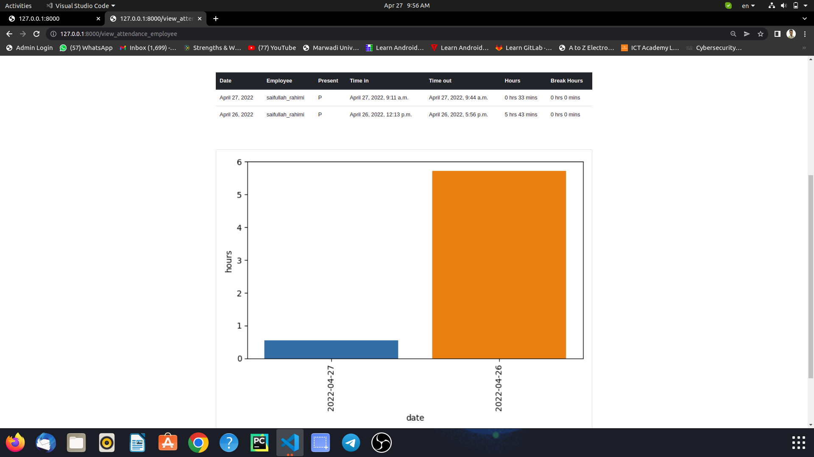

Figure 5. Tabular Representation of attendance data

**Data Visualization**

One of the features of this application is that it allows the admin to view attendance data in the form of graphs and plots. For this purpose, Matplotlib and Seaborn libraries have been used. Data is first fetched from the database in the form of query sets, using Django. Query sets can be converted to Pandas dataframe objects using the django_pandas library. These data frames are then used as direct inputs to Seaborn graphing functions.

**Matplotlib and Seaborn**

Matplotlib is a 2D Python 2D plotting library that can be used to generate plots, histograms, power spectra, bar charts, error charts, scatterplots, etc. from datasets. Seaborn is a graphical library built on top of Matplotlib. Seaborn provides a high-level interface to draw statistical graphics. Seaborn functions operate on data in the form of Pandas dataframes.

Both Matplotlib and Seaborn are pip installable.

pip install matplotlib seaborn

Examples

1. A Seaborn bar plot demonstrating the number of hours worked by each employee on a particular date is displayed in the following figure.

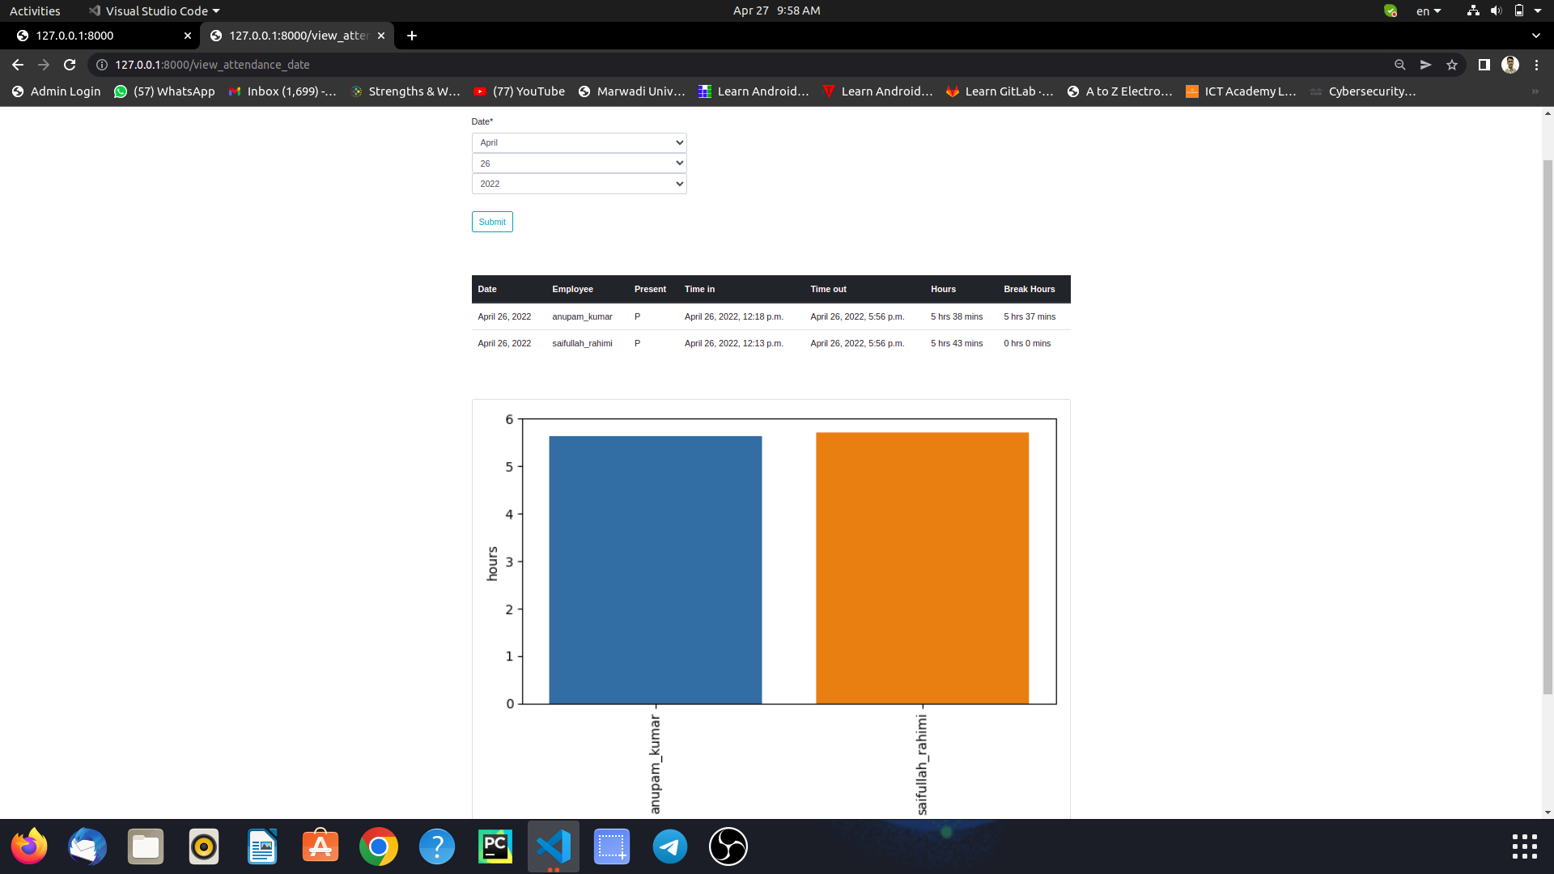

Figure 6. Hours worked vs. username for a particular date

2. A Seaborn line plot demonstrating the number of hours worked by a particular employee for a range of dates is displayed in the following figure. Note that it allows easy visualization of the weekly minimum.

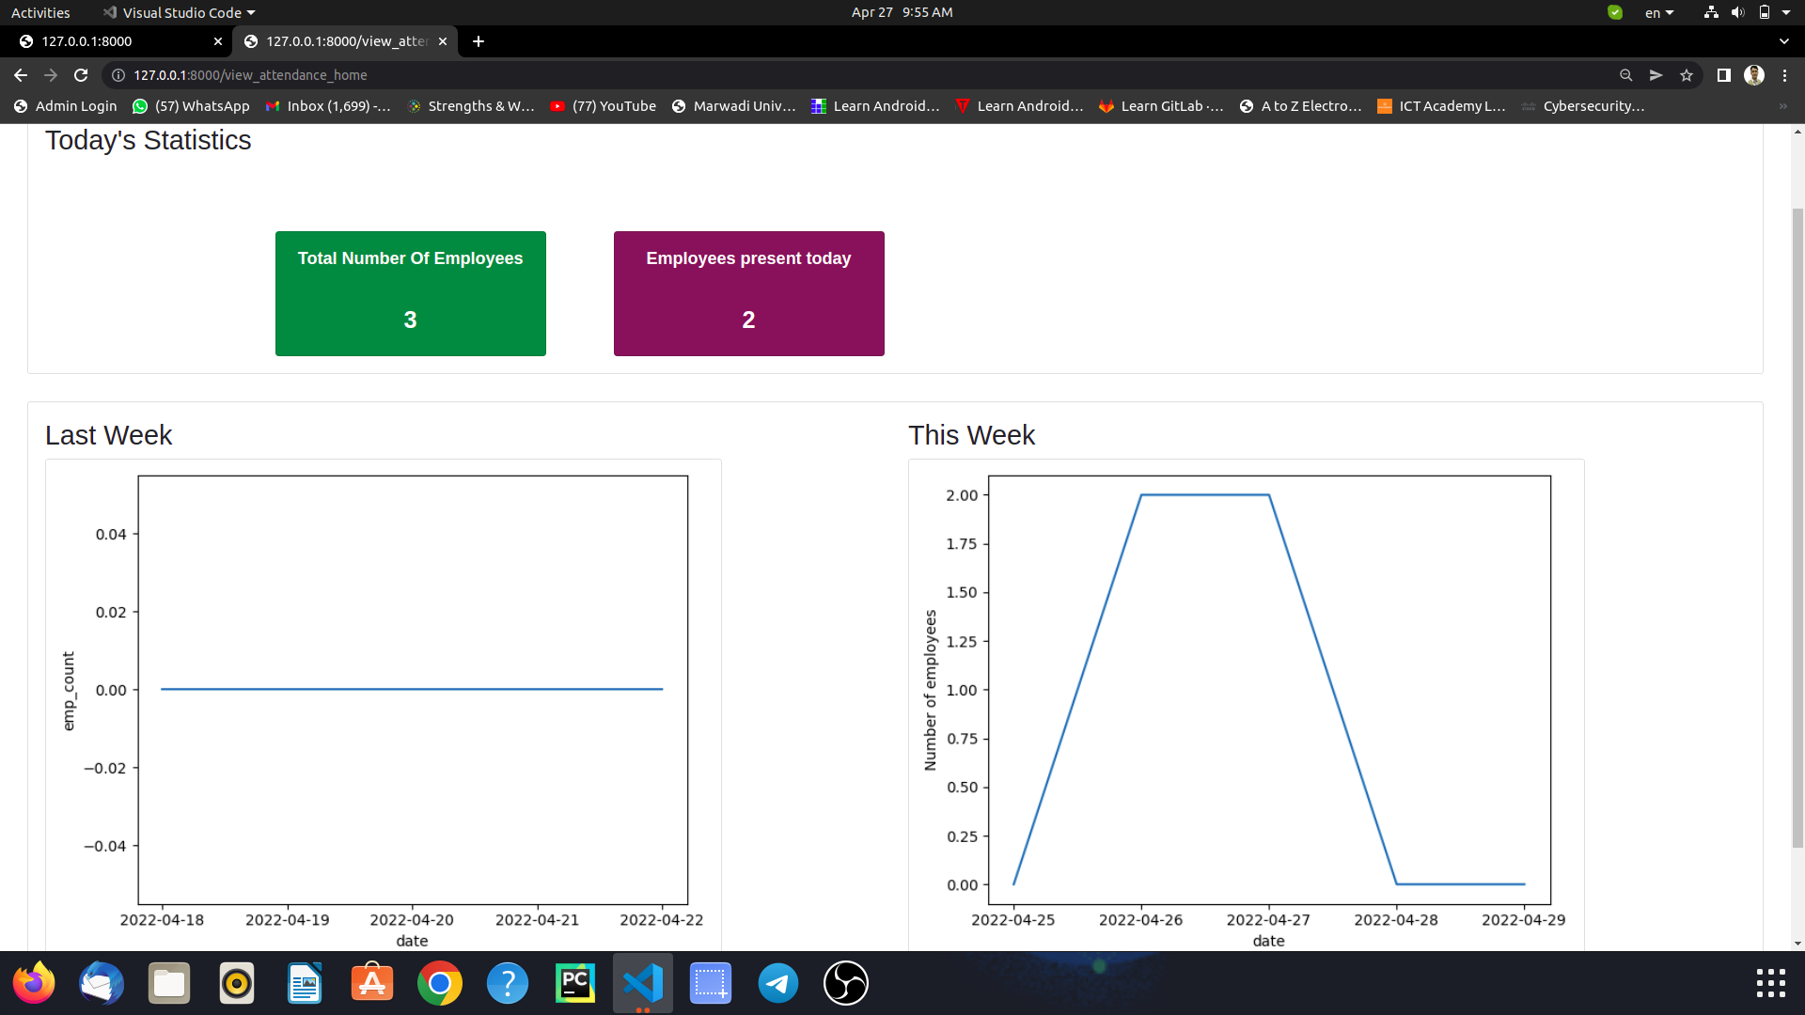

Figure 7. Hours worked vs. Date for a particular employee

**4. Technical Description**

The following sections will introduce the numerous requirements of the system from the point of view of different users and will introduce a number of decisions that have been made regarding implementation.

**4.1 Hardware Requirement:-**

##### Hardware Interfaces

##### I3 processor-based computer or higher

##### Memory: 3GB RAM

##### Hard drive

##### Working Web camera with clear image

## Technology/Platform/Tools used

**Libraries :**

* OpenCV
* Dlib
* Open-Source Face Recognition Library
* JavaScript
* Bootstrap
* imutils
* numpy
* scikit-learn
* seaborn
* matpotlib

**Framework:-**

* **Django**

**Database**

* **SQLite**

**Platform:**

* Windows
* Linux

**Tools:**

* Visual Studio Code

**4.2 Software Requirement:**

##### Software Interfaces

##### Windows or Linux Operating System

##### Client-side Browser Support

##### Server-side Django + SQLITE Database Support

##### Communications Interfaces

##### Communication Standard: HTTPS

##### Network Server: Localhost

##### Chrome / Mozilla Web Browser

**5. System Design and Development**

**5.1 System Flow:-**

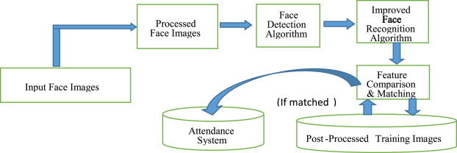

Figure 8. System Flow

**5.2 Data Flow Diagrams:-**

**System Context Diagram**

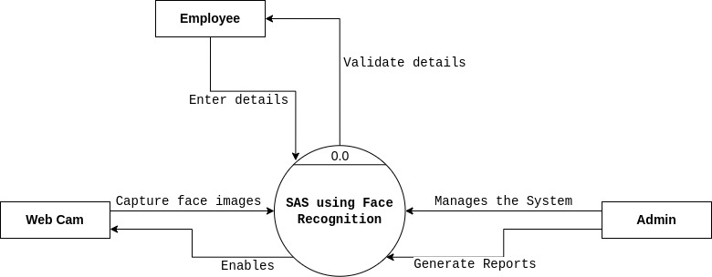

Figure 9. System Context Diagram

**DFD Level 0:-**

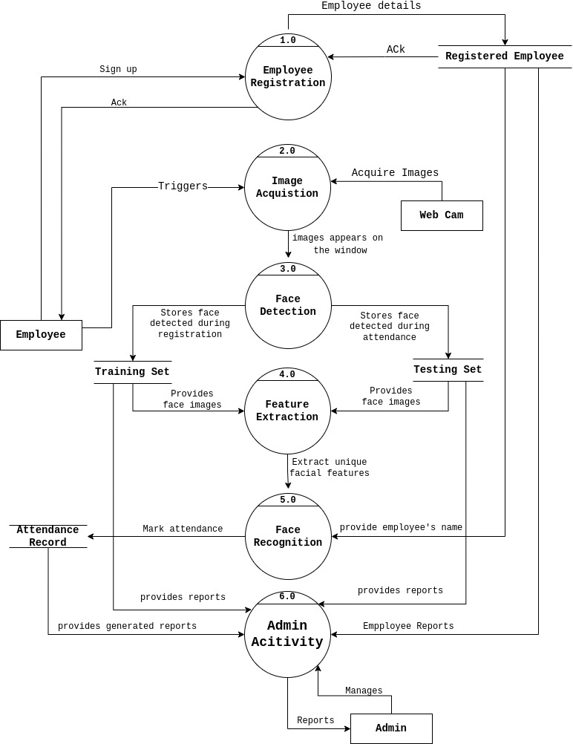

Figure 10. DFD 0

**5.3 Structural Modeling:-**

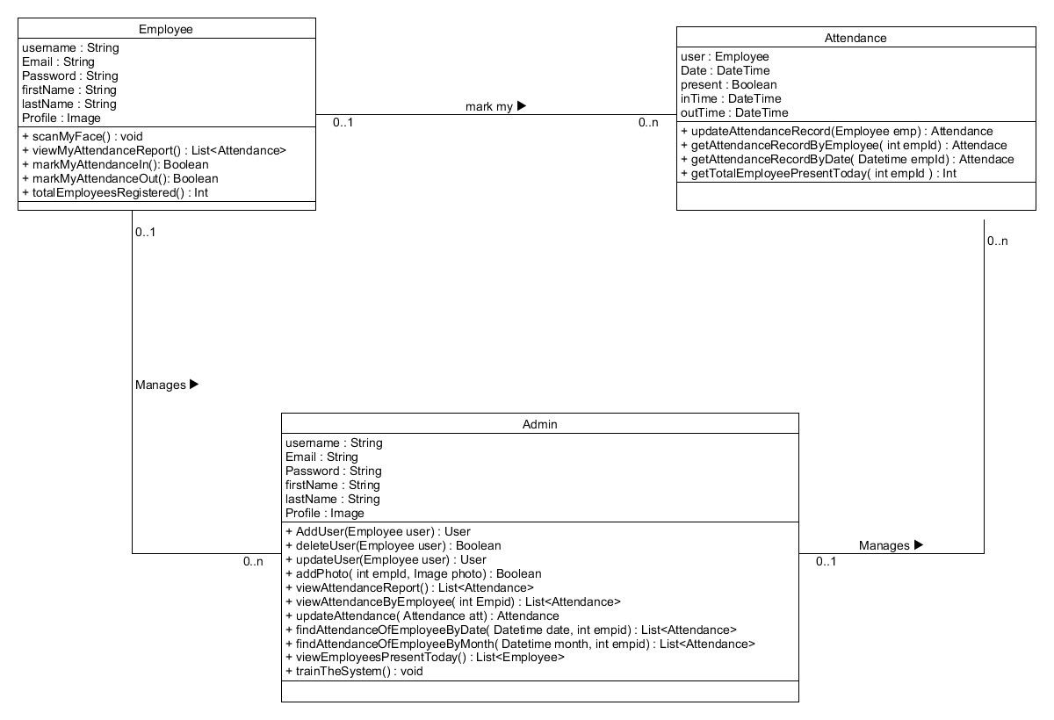**5.3.1 Class Diagram**

Figure 11. Class Diagram

**5.4 Behavioral Modeling**

**5.4.1 Use Case Diagram**

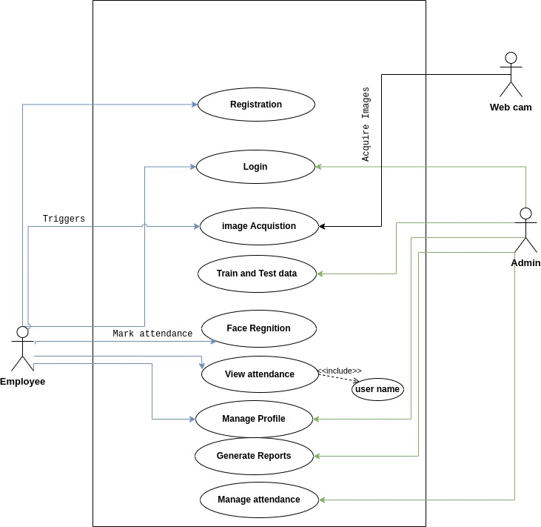

Figure 12. Use Case Diagram

**5.4.2 Sequence Diagrams**

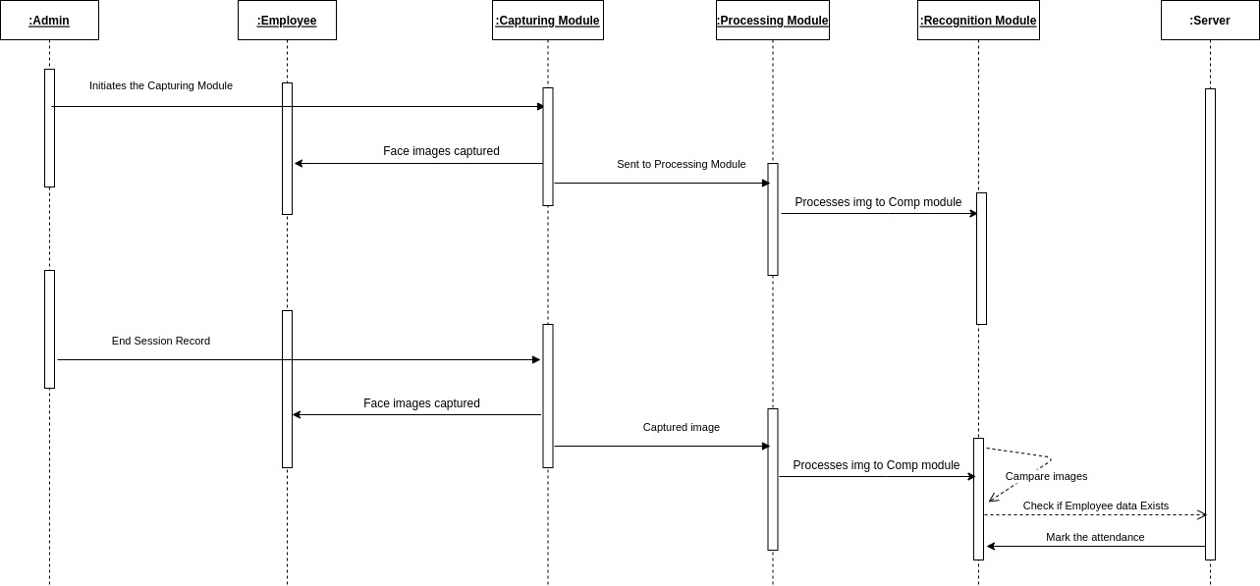

Figure 13. Squence Diagram

**5.4.3 Activity Diagram**

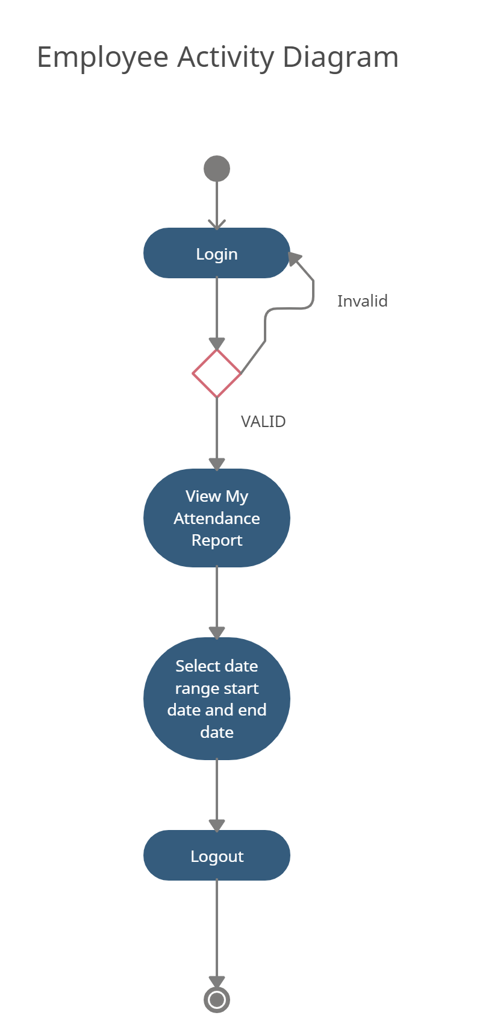

Figure 14. Employee Activity Diagram

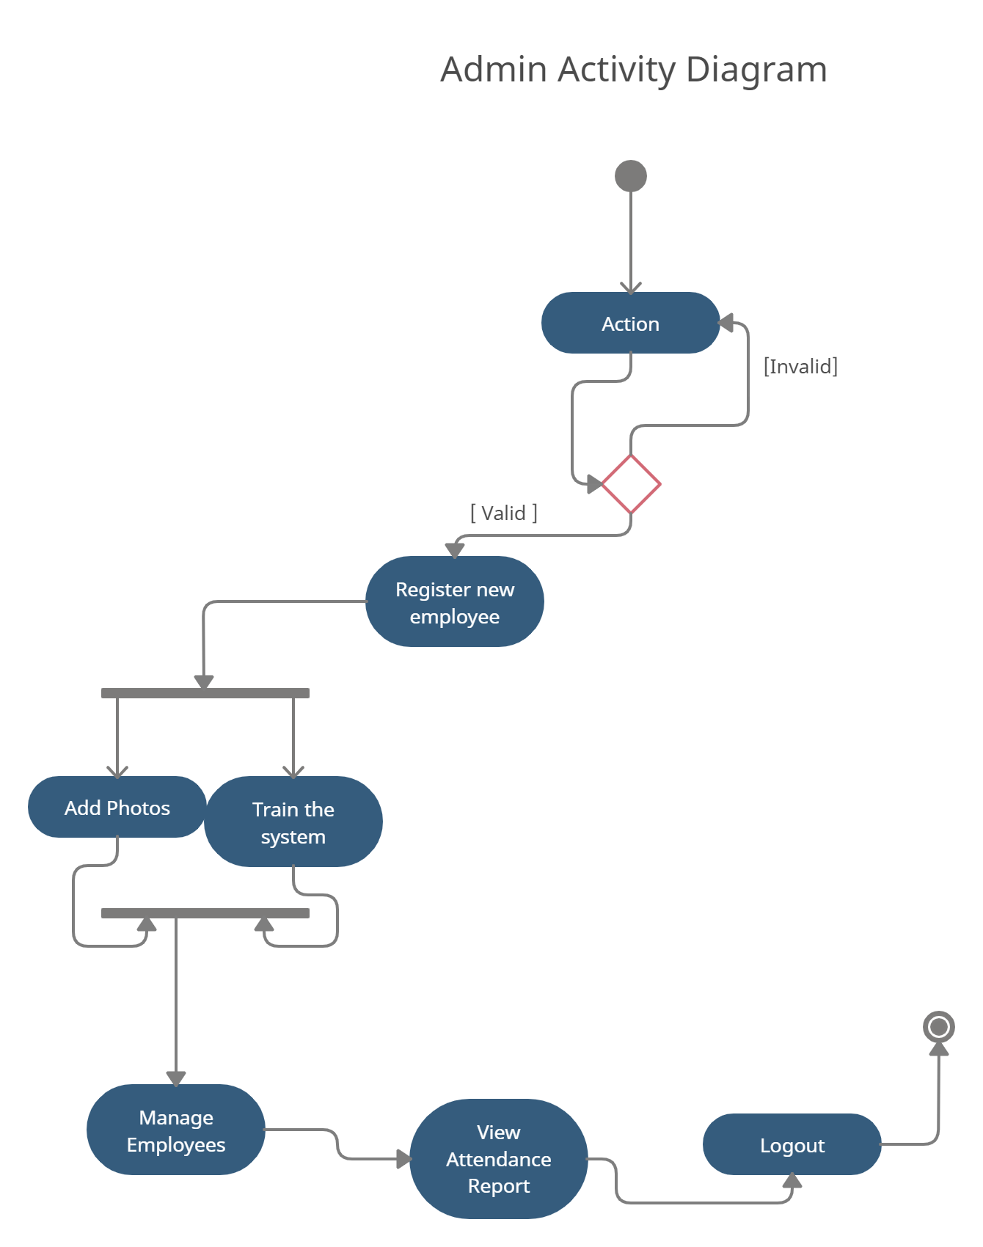

Figure 15. Admin Activity Diagram

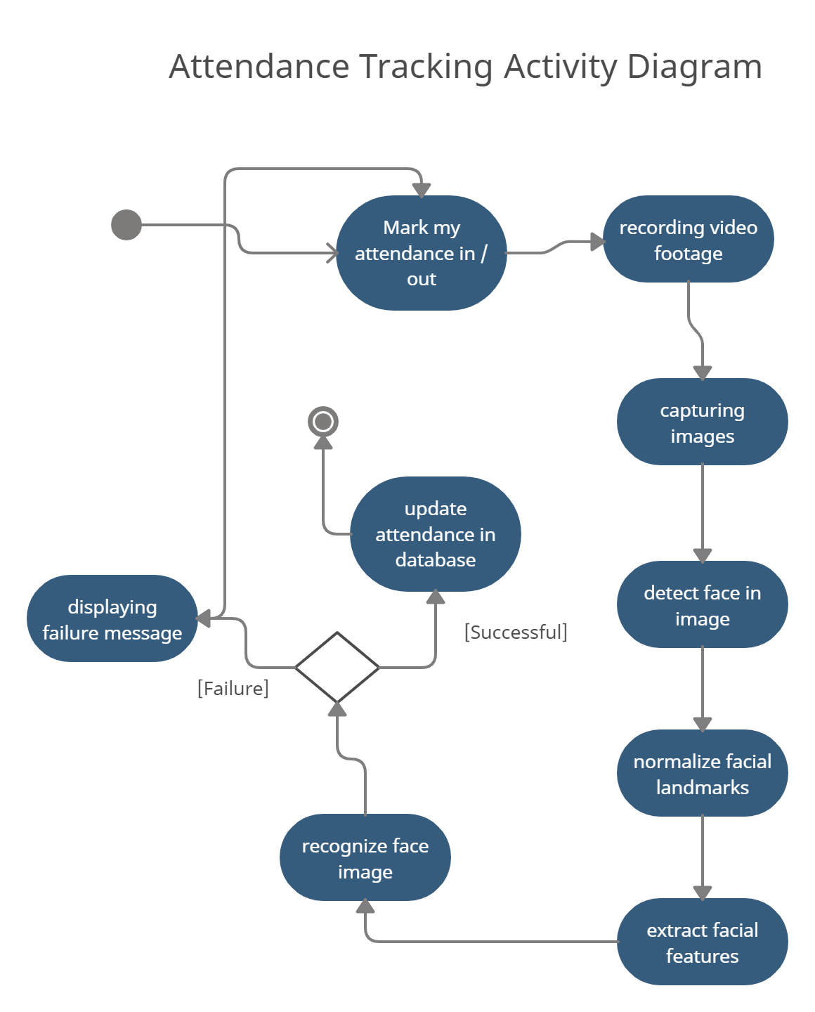

Figure 16.Attendance Tracking Activity Diagram

**5.5 Database Design:-**

**5.5.1 Table Structure**

### User

|  |  |  |  |  |  |  |
| --- | --- | --- | --- | --- | --- | --- |
| **No** | **Field name** | **Data type** | **Required** | **Unique** | **PK / FK** | **Ref. Table** |
| 1 | UserId | int | true | true | PK | - |
| 2 | Email | string | true | true | - | - |
| 3 | Name | string | true | false |  | - |
| 4 | Password | string | true | false | - | - |
| 5 | CreatedAt | Datetime | true | false | - | - |
| 6 | UpdatedAt | Datetime | True | False | - | - |

Figure 17. User Data Table

### Present

|  |  |  |  |  |  |  |
| --- | --- | --- | --- | --- | --- | --- |
| **No** | **Field name** | **Data type** | **Required** | **Unique** | **PK / FK** | **Ref. Table** |
| 1 | PId | int | true | true | PK | - |
| 2 | Date | Datetime | True | False | - | - |
| 3 | User | User | True | False | FK | Users |
| 4 | Present | Boolean | True | False | - | - |

Figure 18. Present Data Table

### Time

|  |  |  |  |  |  |  |
| --- | --- | --- | --- | --- | --- | --- |
| **No** | **Field name** | **Data type** | **Required** | **Unique** | **PK / FK** | **Ref. Table** |
| 1 | TId | int | true | true | PK | - |
| 2 | Date | Datetime | true | True | - | - |
| 3 | User | Users | True | False | FK | Users |
| 4 | Time | Datetime | False | False | - | - |
| 5 | Out | Boolean | True | False | - | - |

Figure 19. Time Data Table

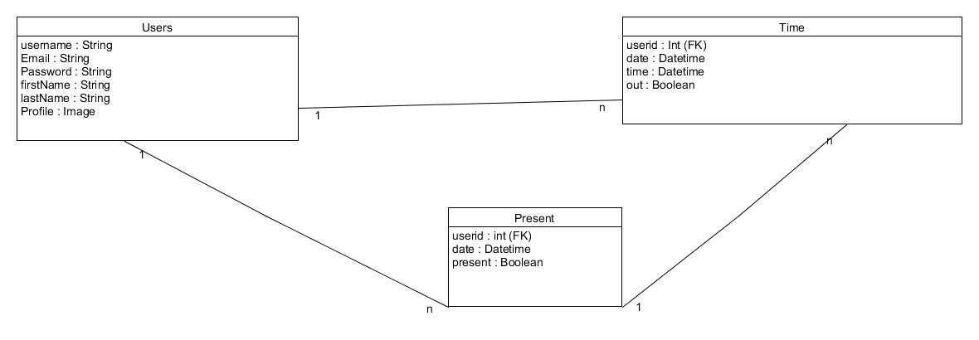**5.5.2 Entity Relationship Diagram**

Figure 20. Entity Relationship Diagram

**5.6 Screen Designs:-**

**5.6.1 Admin Screen Designs:**

**Login page**

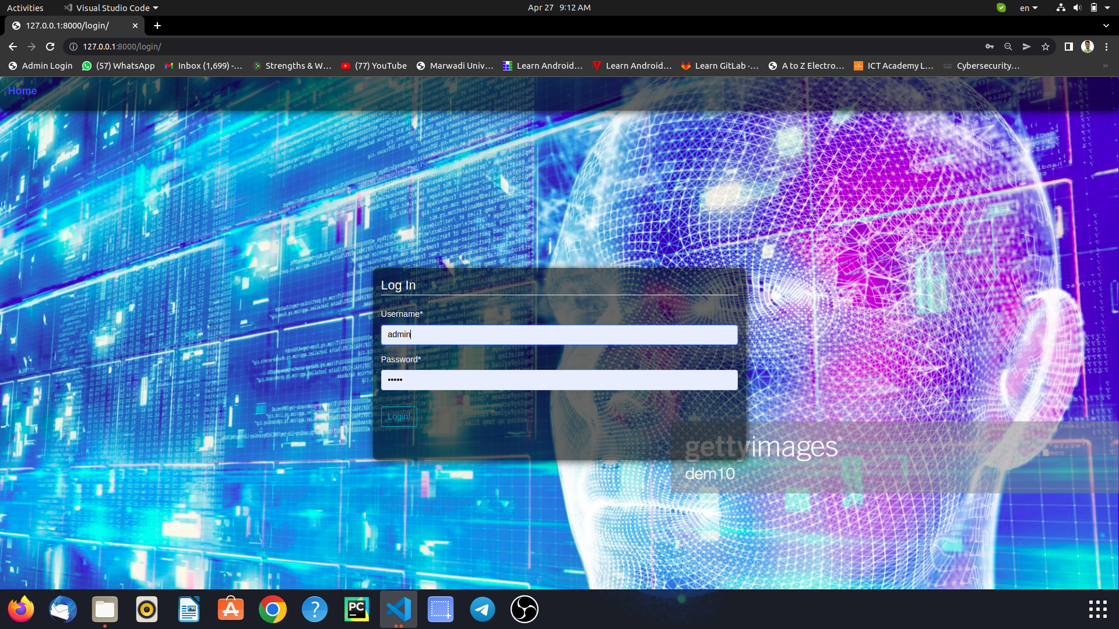

Figure 21. Admin Login Page

**Dashboard**

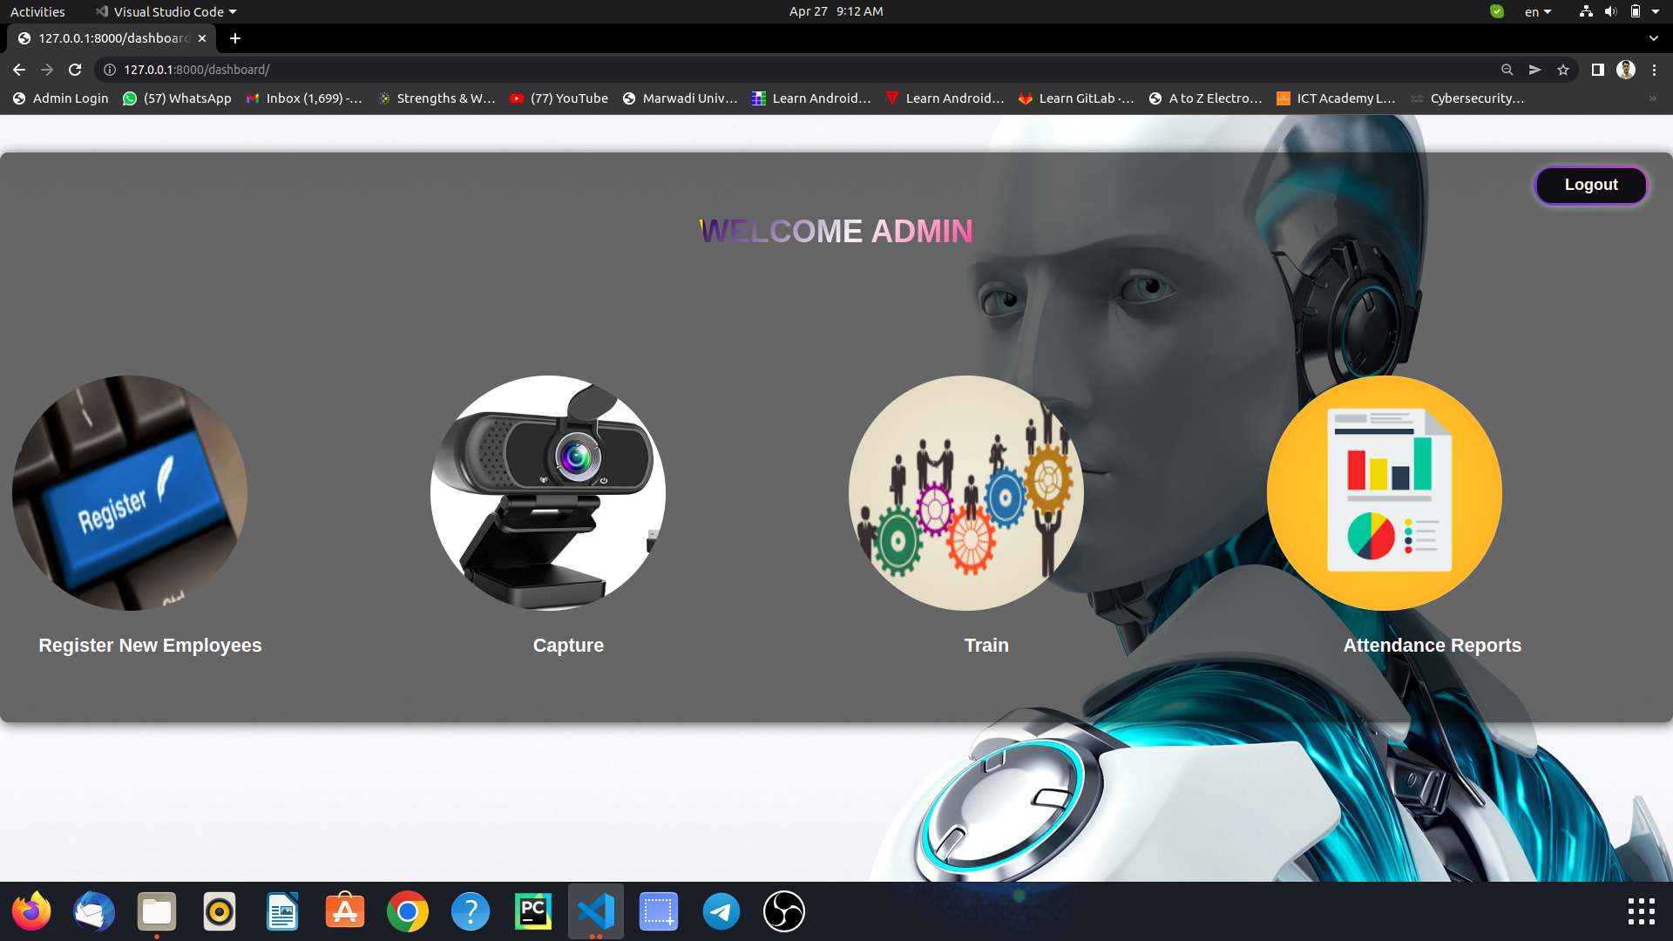

Figure 22. Admin Dashboard Page

**Manage Report**



Figure 23. Report Dashboard Page



Figure 24. View Report by Date



Figure 25. View Report of Each Employee

**New Employee Registration & Validation**

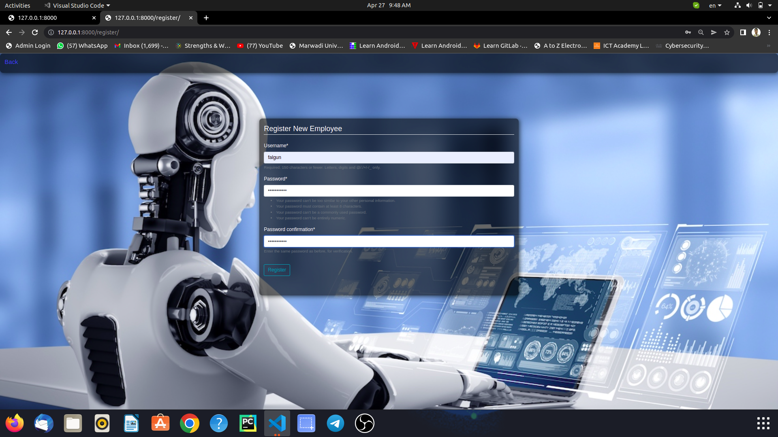

Figure 26. New Employee Registration

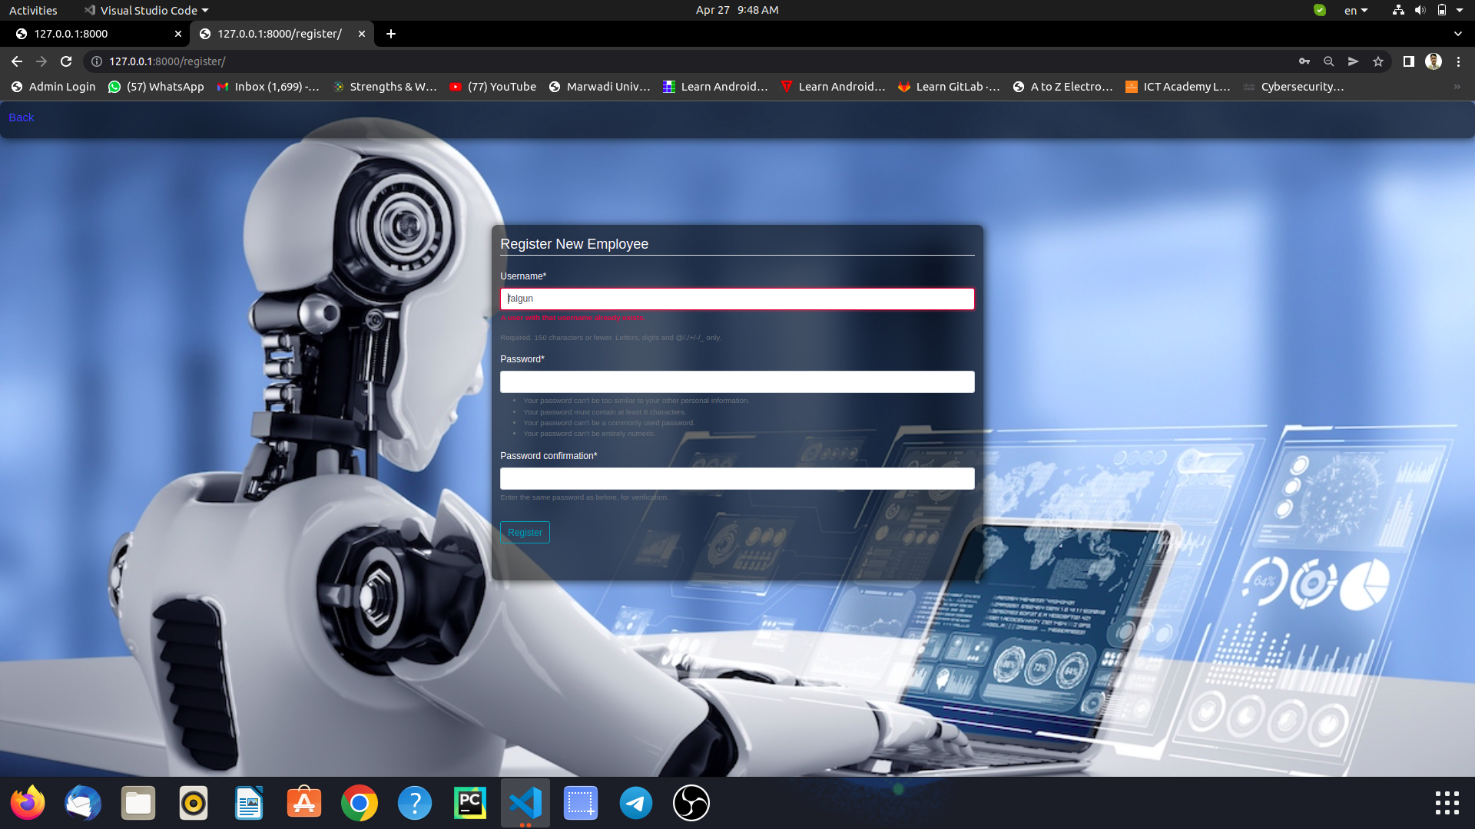

Figure 27. Page Validation 1

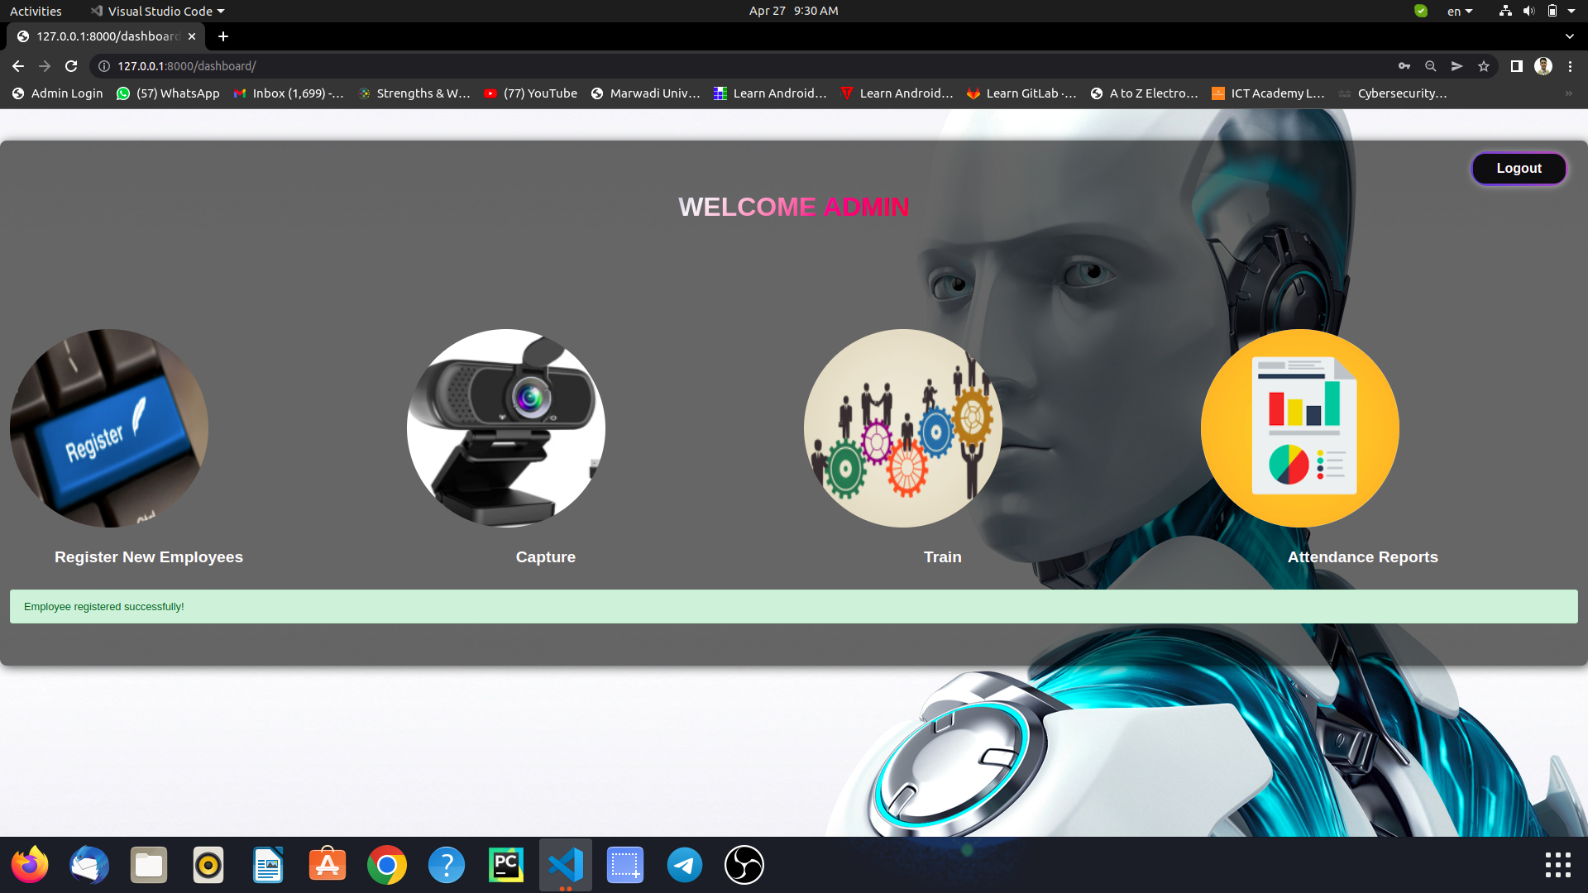

Figure 28. Page Validation 2

**Employee Face Capturing & Validation**

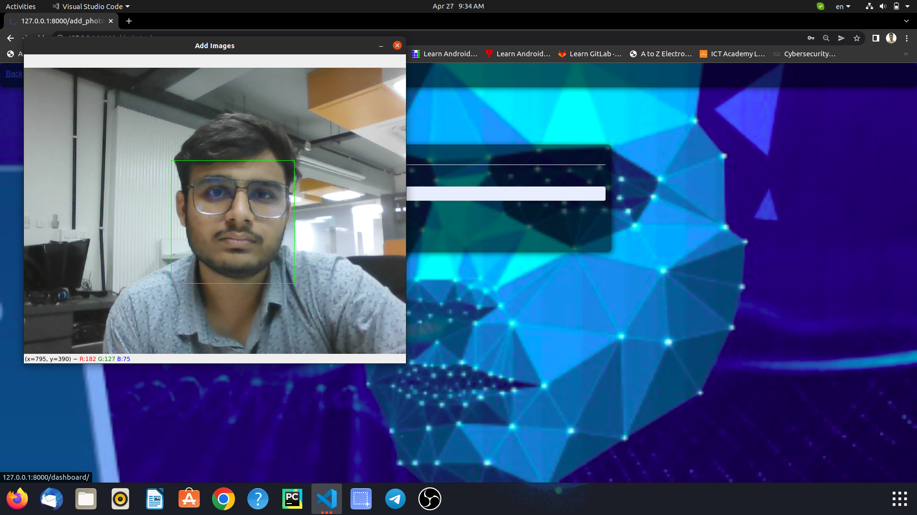

Figure 29. Employee Face Capturing

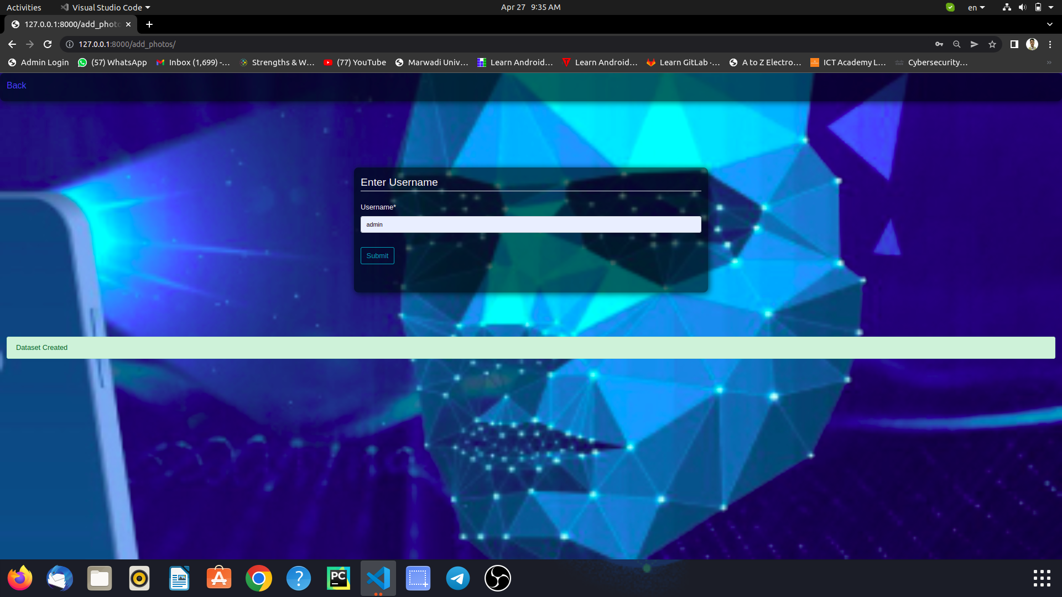

Figure 30. Validation

**Data Training**

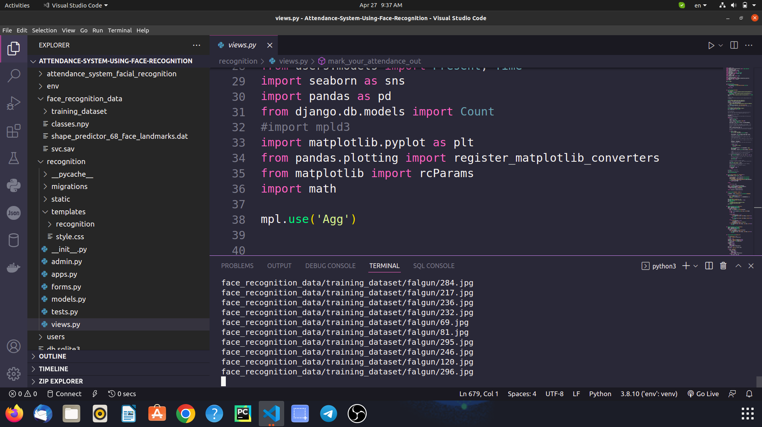

Figure 31. Emplyee Face Data Training

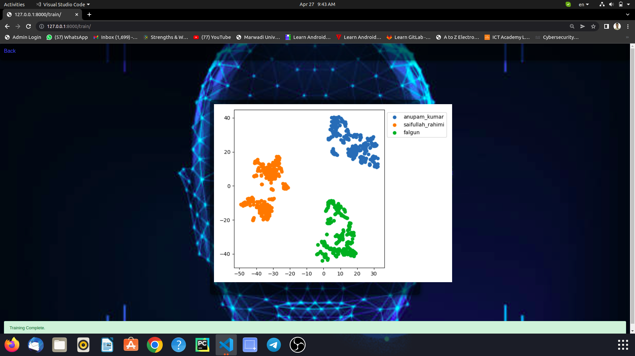

Figure 32. After Successful Training pop up page

**5.6.2 Database Management Screen Design:-**

**Login page**

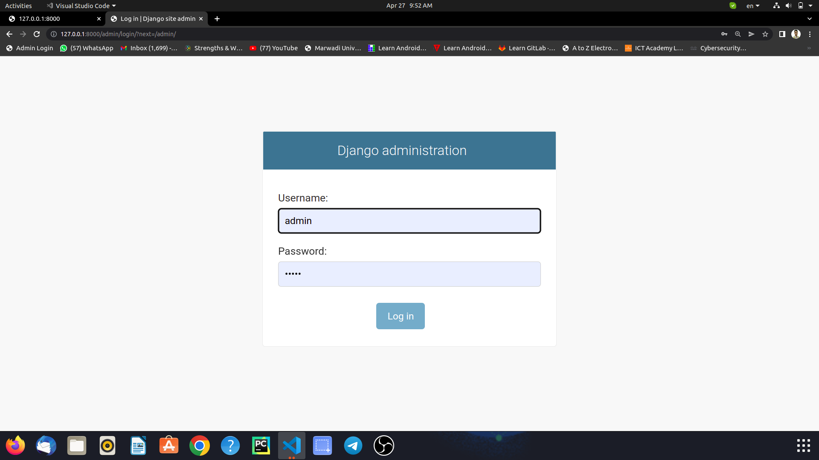

Figure 33. Login Page

**Django Administration Dashboard**

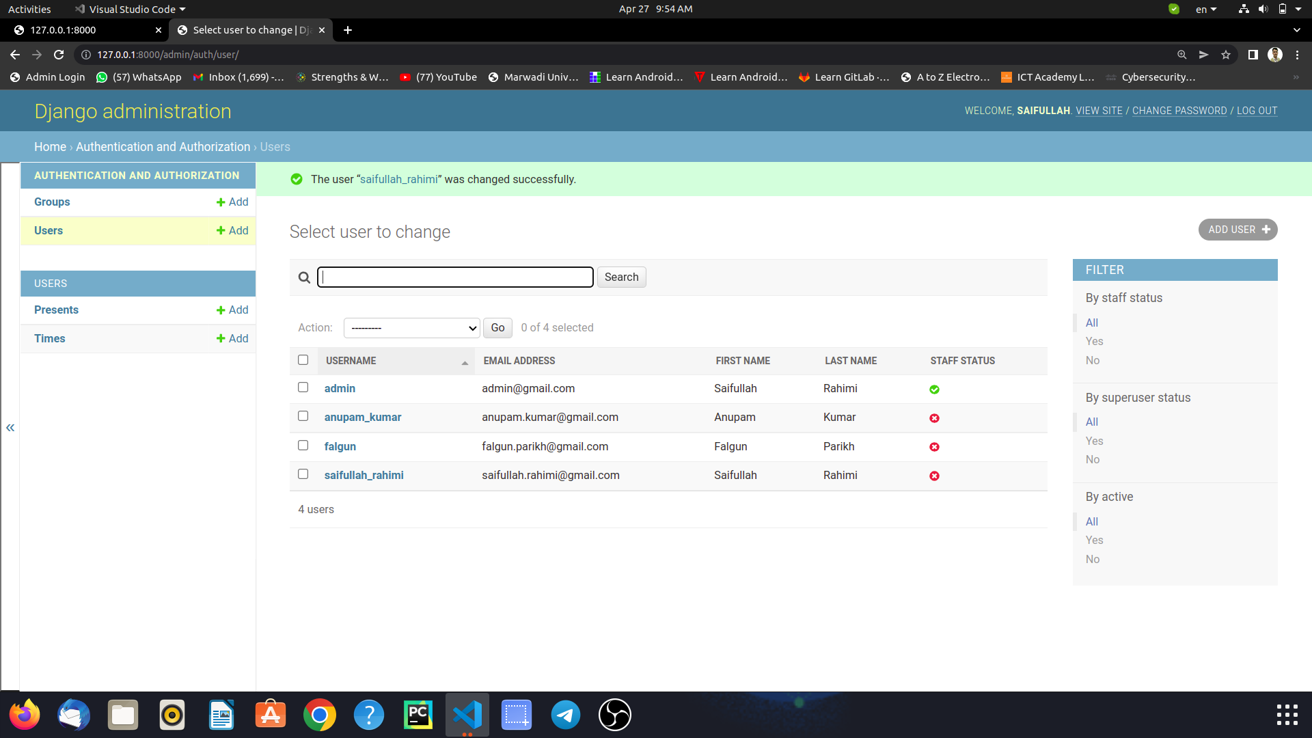

Figure 34. Django Administration Dashboard

**Change password**

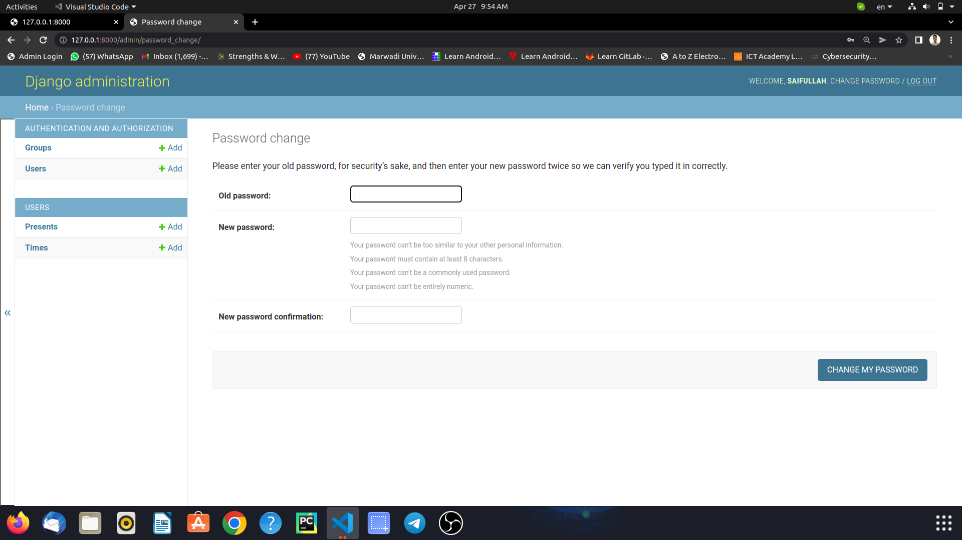

Figure 35. Change Password Page

**Manage User Details**

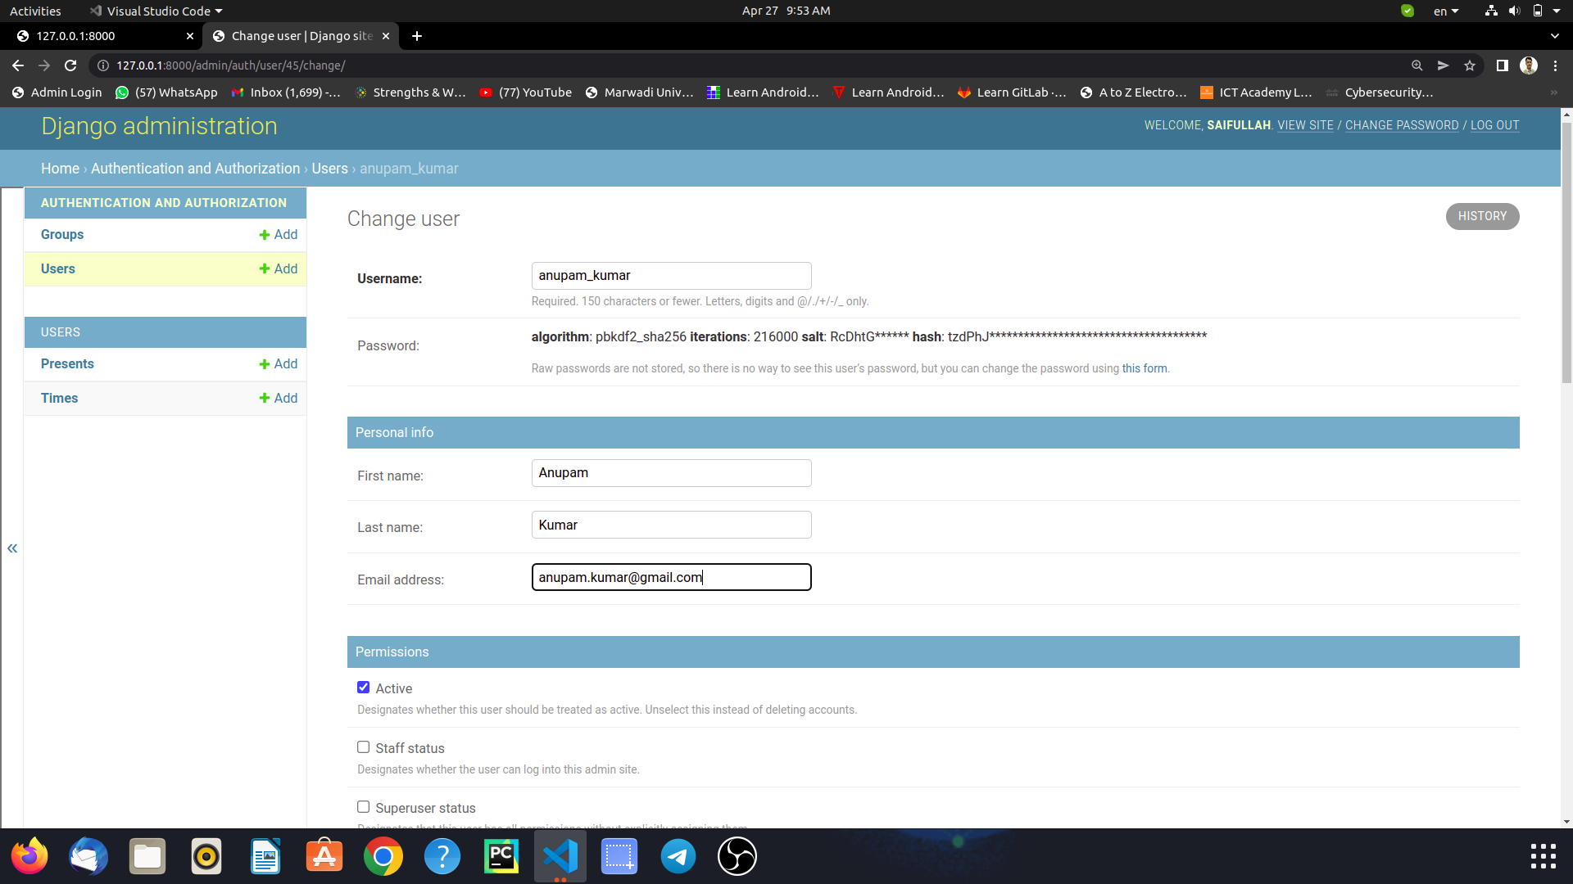

Figure 36. Manage User Details

**5.6.3 Employee Screen Design:-**

**Home page**

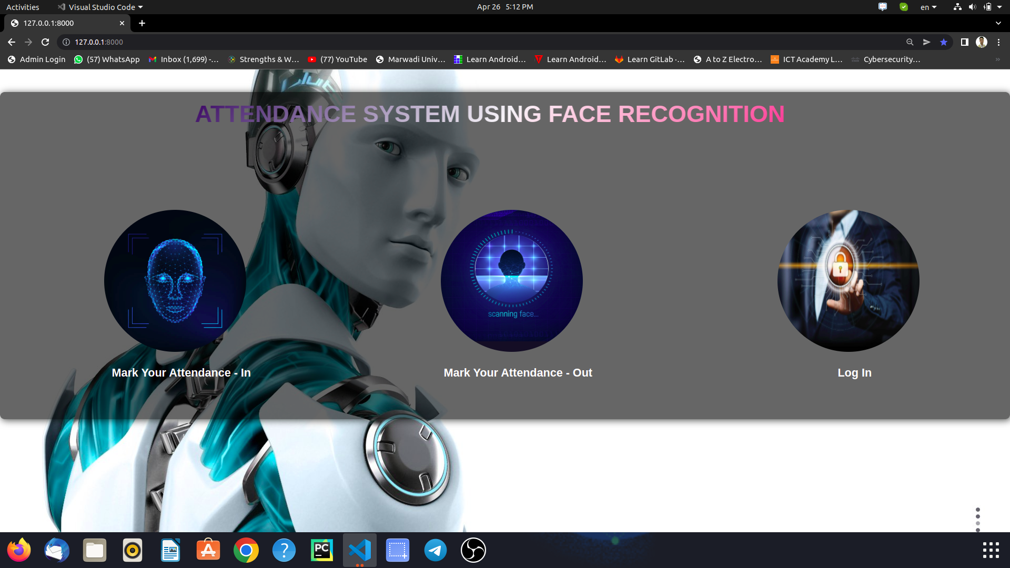

Figure 37. Home Page

**Mark Attendance Pop up**

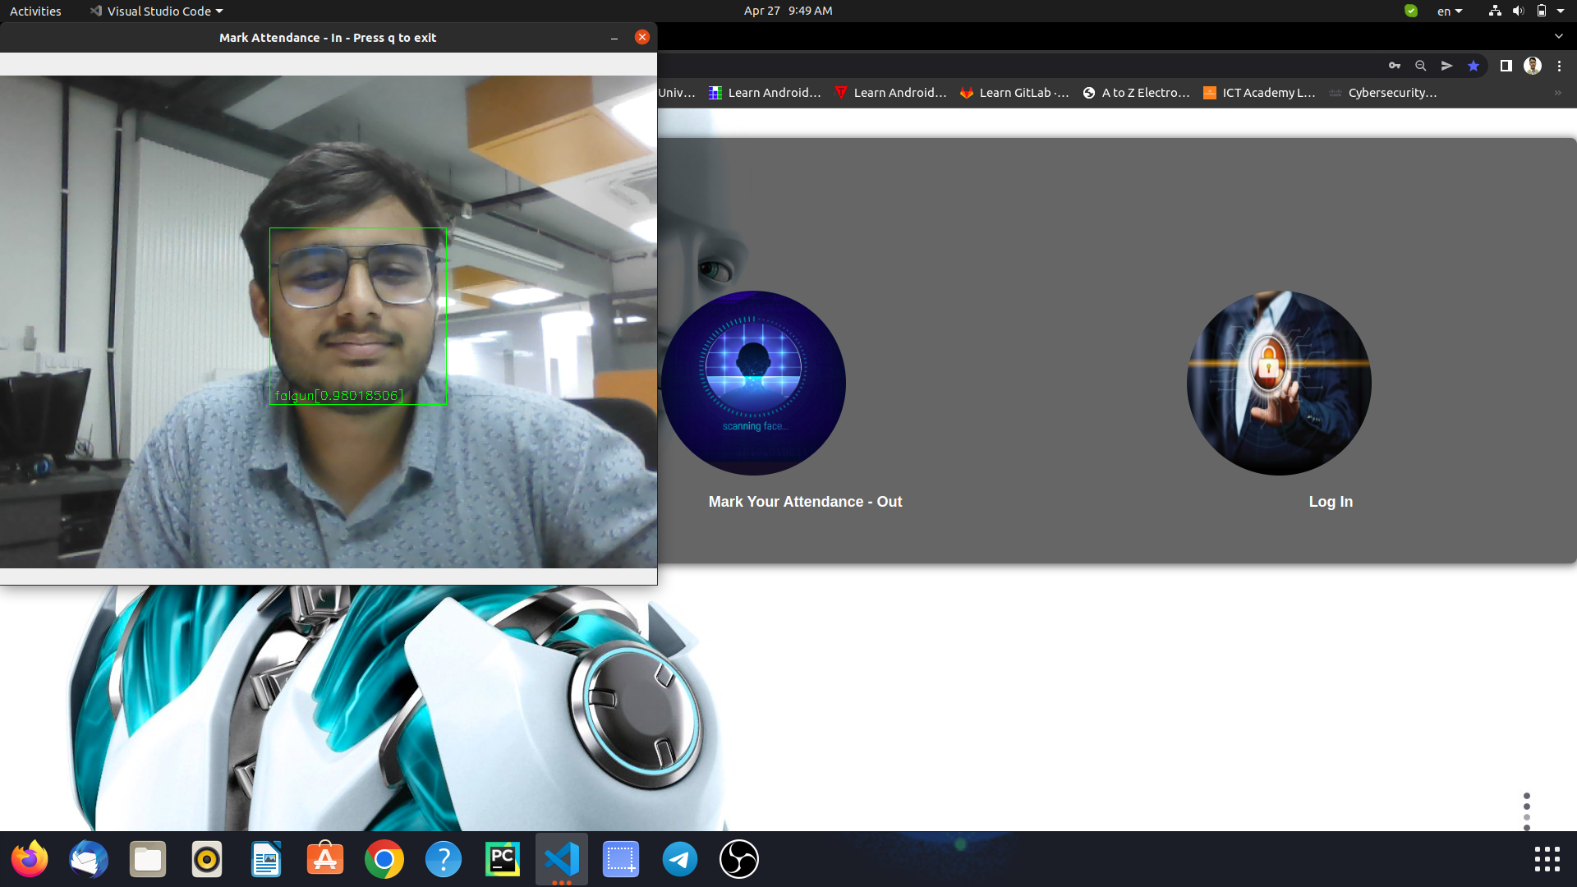

Figure 38. Mark Attendance pop up

**Employee Login Page**

**Employee Dashboard**

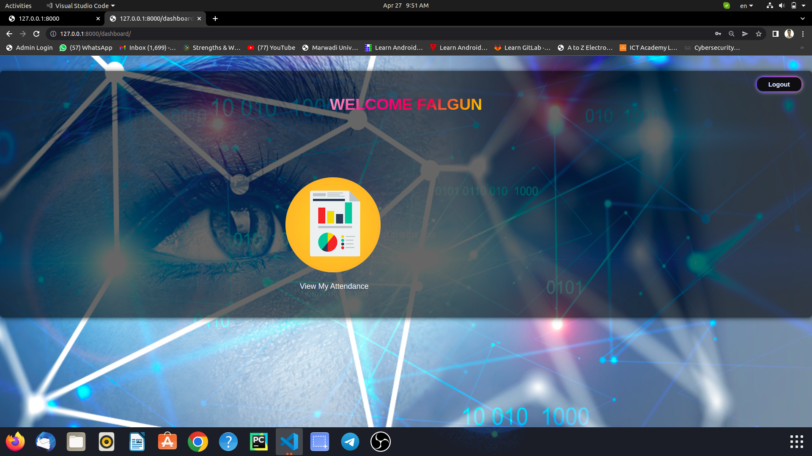

Figure 39. Dashboard Page

**View attendance report**

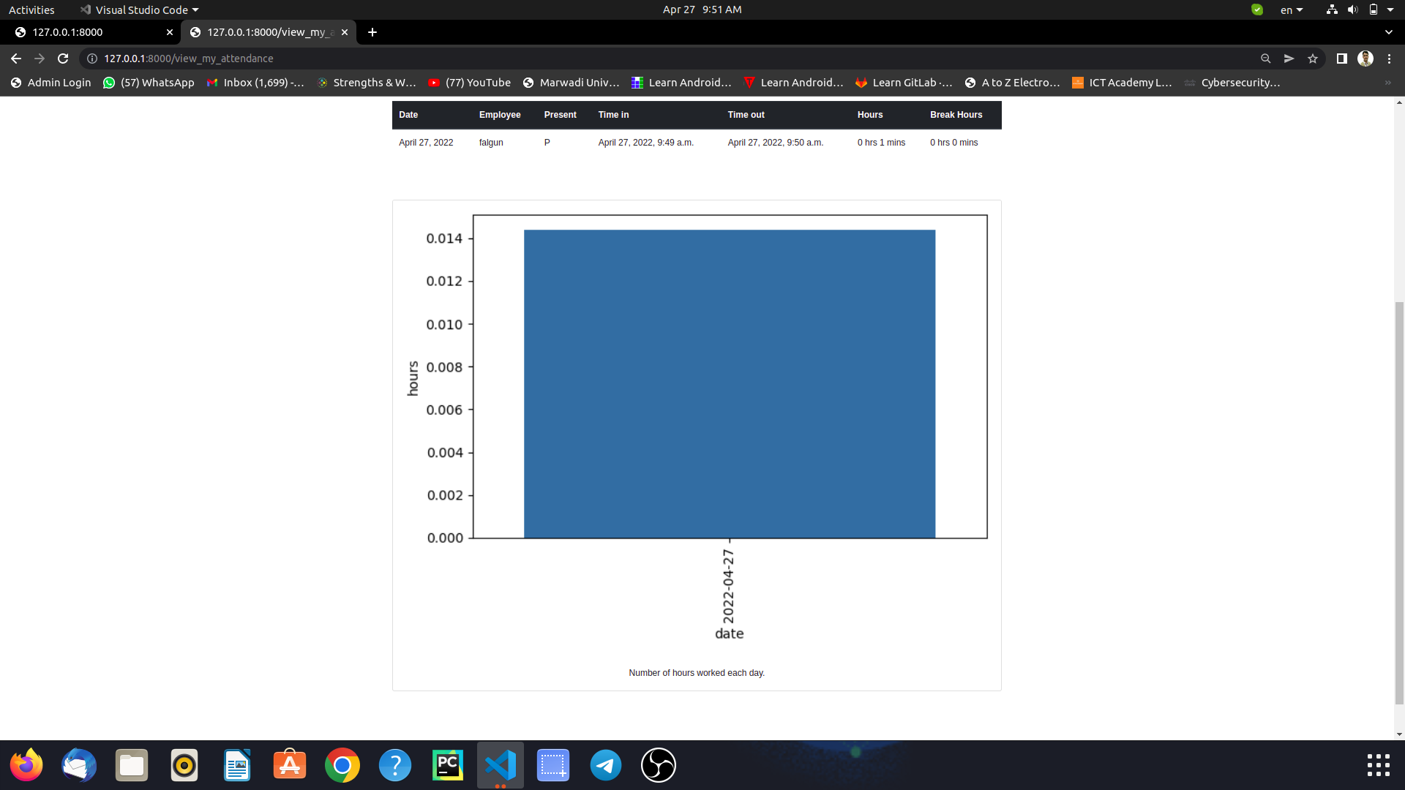

Figure 40. Attendance Report

**6. SYSTEM TESTING**

**6.1 Testing and Implementation**

**Models of Testing:**

There are different models of testing. On the basis of testing methods there are two type of testing:

* **Black-box testing**
* **White-box testing**

Black-box tests are used to demonstrate the software function are operational, that input is properly accepted and output is correctly produced, and that integrity of external information is maintained.

White-box tests are used to examine the procedural details. It checks the logical paths by test case. It can also check the conditions, loops used in the software coding. It checks that loops are working correctly on defined boundary values.

1. **Black-box testing**

Black-box testing focuses on the functional requirement of the software. The black-box testing enables the software engineer to drive sets of input condition that will fully exercise all functional.

Requirements for the program. Black-box testing is not an alternative to white-box testing techniques. Rather; it is complementary approach that is likely to uncover a different class of error than white-box methods.

We use in our coding to find error in the following categories

• Incorrect or missing functions.

• Interface errors.

• Performance errors.

Unlike White-box testing, which is performed earlier in the testing process black-box testing tends to be applied during later stages of testing. Because black-box testing purposely disregards control structure, attention is focused on the information domain.

By applying black-box techniques, we derive a set of test cases that satisfy following criteria.

Typical Black box test design technique includes: -

* Functional Testing
* Non-Functional Testing
* Regression Testing

1. **White-box testing**

White-box testing sometime called glass-box testing, is a test case design method that users the control structure of the procedural design to drive the test case.

Always we are thinking that is no execute or checks the loops and Conditions. And so large number of error is uncovered.

* All independent paths within a function have been executed at least once.
* All logical decisions on their true and false side.
* All loop working correctly at their boundary values and within their specified conditions.

In SDMS coding we test that all loop works truly in each module. The one technique of white-box testing is basis path testing

Typical White box test design technique includes: -

* Control testing
* Data flow testing

**6.4 System Implementation Strategy**

# **Testing**

Unit testing of each module was done after successfully completing the module. Each module was tested individually before integrating them with the whole system.

After integrating each module with the system, integration testing was done in order to check if modules are working properly together.

After completing all integration s, black-box testing of the whole system was carried out to ensure the system works in a correct manner.

**Black box testing of Major functions of the system**

### Log in to the system.

**Case 1:** Invalid Username or password entered by the Employee.

**Output:** Error message on the screen saying “Invalid credentials”

**Case 2:** Valid credentials.

**Output:** The Employee is redirected to the Dashboard page.

### Update Profile

**Case 1:** username already exists.

**Output:** Error message on the screen saying “Username already exists”

**Case 2:** Some of required fields missing in input.

**Output:** Model validation errors will be displayed to the user.

**Case 3:** All input data are valid.

**Output:** Profile updated successfully.

### View Attendance

**Case 1:** Employee is not logged in.

**Output:** Redirected to the login page with error message “Please login!”.

**Case 2:** If a Employee exists and has the attendance records.

**Output:** All the chat history will be displayed

**Case 4:** Provided username does not exists in the system.

**Output:** 404 Error.

**7.Conclusion**

There may be some error or some defect in the work. I have taken enough care to make the project user friendly and more interactive. I have tried my level best to make the service useful and to provide maximum facility but I never claim that this system may fulfil all requirement in every condition. I hereby conclude these reports which give information regarding the development and the user of application with an overview of different aspect of it.

**8. Learning During Project Work**

Smart Attendance System Using Face Recognition was quite challenging for me as this project include much enough functionalities and components of AI Concepts. So this project enabled me to learn new concepts in various parts which i will point out some of them here:

Learnt to demonstrate skill and knowledge of current information and technological tools and techniques specific to the professional field of study.

Learnt to identify,analyze and solve problems creatively through sustained critical investigation.

Learnt to integrate information from multiple sources.

I realized that practice the skills, diligence, and commitment to excellence needed to engage in lifelong learning.

**9. Future Enhancements**

I think that not a single project is ever considered as complete forever because our mind is always thinking new and our necessities also are growing. if you see at the first glance that you find it to be complete but we want to make it still mature and fully automatic. The system is modified in future as per the owner requirement.

1. A feature which can give intruder alert can be included in the system. Furthermore, theimages of unknown people can be saved in an efficient manner and displayed in the systemfor better security.

2. The number of training images can be reduced so that less storage is required. This can bedone by removing duplicate images of the same person, or images with similarembeddings.

3. The training time can be reduced by retraining the classifier only for the newly addedimages.

4. A feature can be added where an employee is automatically sent a warning if hisattendance or working hours are below the threshold.

5. Wrongly classified images can be added to the training dataset with the correct label so asto increase the accuracy of the recognition model.

**10. Bibliography**

Bibliography means that we have referred while doing project like, which sites we gone through and which books we have referred or which magazines we have seen to implements this project. There are many books and websites that can help us proper guild line to implements my system in the right direction.

**10.1 Online References**

1. King, Davis. “High Quality Face Recognition with Deep Metric Learning.” Dlib, blog.dlib.net/2017/02/high-quality-face-recognition-with-deep.html.

2. Krasser, Martin. Deep Face Recognition with Keras, Dlib and OpenCV. krasserm.github.io/2018/02/07/deep-face-recognition/.

3. Kumar, Satyam. “Face Recognition Using OpenFace.” Medium, [medium.com/@krsatyam1996/face-recognition-using-openface-92f02045ca2a](mailto:medium.com/@krsatyam1996/face-recognition-using-openface-92f02045ca2a). Link to Bootstrap website - for CDN add later

5. Mallick, Satya. “Histogram of Oriented Gradients.” Learn OpenCV, www.learnopencv.com/histogram-of-oriented-gradients/.

6. Pupale, Rushikesh. “Support Vector Machines(SVM) — An Overview.” Towards Data Science, towardsdatascience.com/https-medium-com-pupalerushikesh-svm-f4b42800e989.

7. Rosebrock, Adrian. “Face Alignment with OpenCV and Python.” Pyimageserach, [www.pyimagesearch.com/2017/05/22/face-alignment-with-opencv-and-python/](http://www.pyimagesearch.com/2017/05/22/face-alignment-with-opencv-and-python/).

8. Symanovich, Steve. “How Does Facial Recognition Work?” Norton by Symantec, us.norton.com/internetsecurity-iot-how-facial-recognition-software-works.html.

9. ujjwalkarn. “An Intuitive Explanation of Convolutional Neural Networks.” The Data Science Blog, ujjwalkarn.me/2016/08/11/intuitive-explanation-convnets/.

**10.2 Offline References**

**References Books:**

Face Detection and Recognition: Theory and Practice

### Book by Asit Kumar Datta, Madhura Datta, and Pradipta Kumar Banerjee